Tyler Jones
321000444

Texas A&M Hazardous Waste Facility
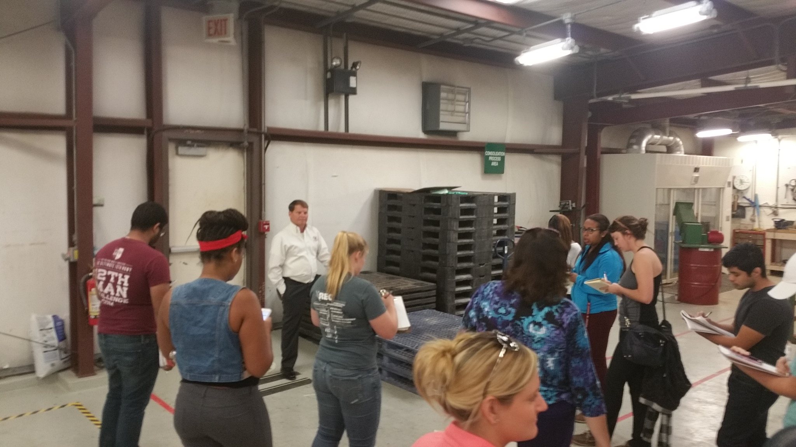

Introduction
On October 23rd a group of thirteen EHSC students along with Dr. Wilkinson toured the Texas A&M Hazardous Waste Facility on campus lead by Dave Rice. In the facility, the group discussed the different rules and regulations as well as the different processes of the facility.
The Texas A&M Hazardous Waste provides hazardous waste removal and disposal services to the University. This facility handles around 4,000 items of waste a quarter. This production is to allow Texas A&M the ability to produce most of its energy needs in house rather than paying larger amounts for it through the grid. This facility was built in 1987 and has been producing power for the university ever since¹.
Below I will expand on the plants features and the different regulations and guidelines used for the facility. This will be done by a superscript relating it the guideline or regulation that pertains to it and where I have obtained that information.

Site Features

The Utility Plant is located at 2655 Dairy Center Rd and serves a population of around 60,000 people. The Facility is composed of a chemical holding area, processing area, packing area and a shipping area. These areas work in a succession to help process and ship out all hazardous wastes that the University produces.
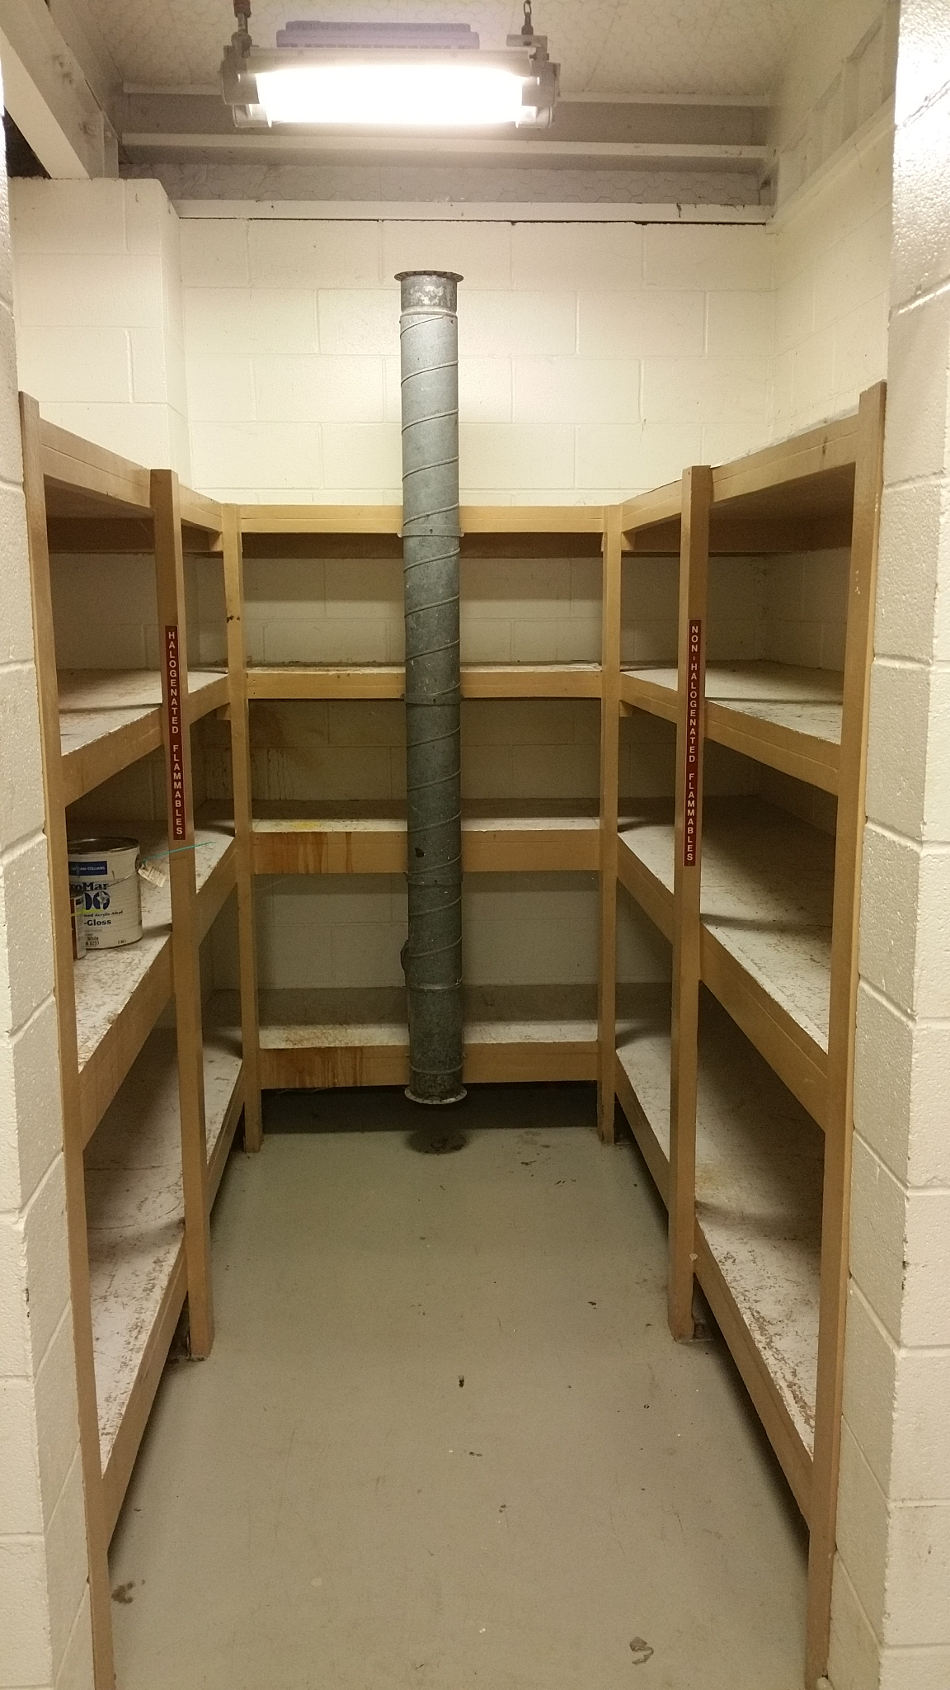
When the facility receives notice of a hazardous waste needing disposal, they have 90 days to pick it up, process and it out. This process includes all identification, labeling and tracking of all chemicals.
Within the holding area, chemicals that are shipped in are held in specified holding areas dependent on their composition (if known). These areas are: Flammables, Caustics and Corrosives, and Toxics (Figure 1).
If a chemical that is delivered is unknown, it is tested within the processing area to determine the flammability, corrosiveness and other hazardous characteristics to determine the type of chemical it is and what type of disposal is proper.
Figure 1: Holding Area for chemicals arriving at the facility.
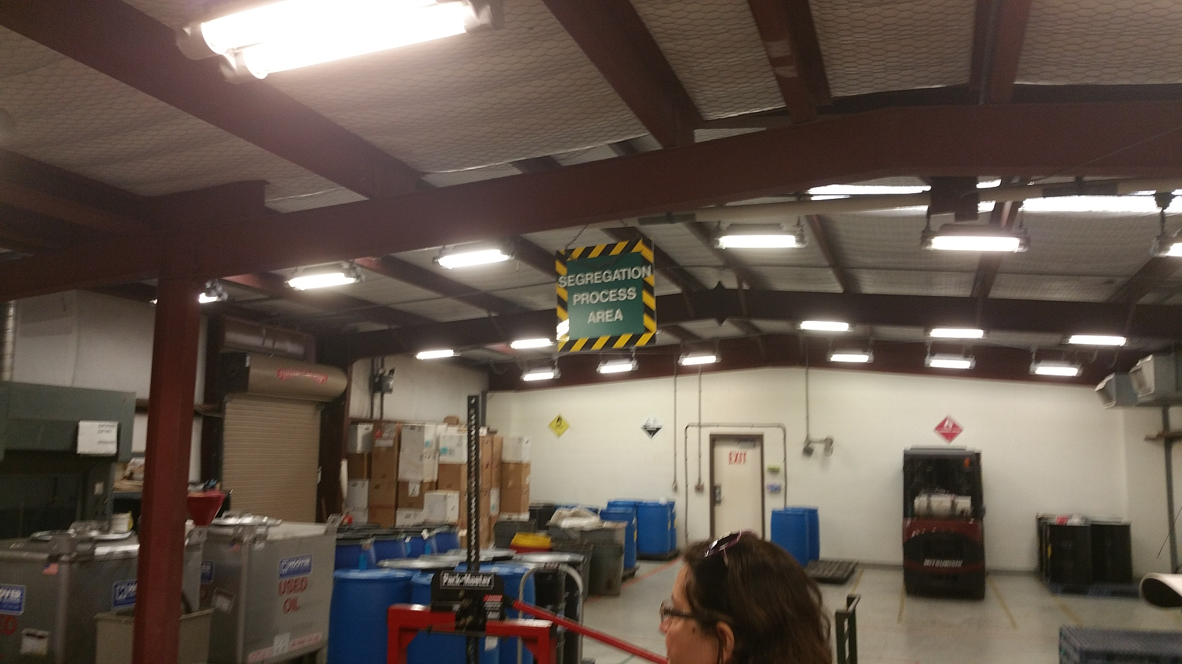
In the packing area, like chemicals with similar characteristics are combined into larger holding containers to be more easily disposed of. Mostly these chemicals are consolidated into large metal barrels (Figure 2).
Figure 2: Consolidation Area, where chemicals are consolidated into larger containers.
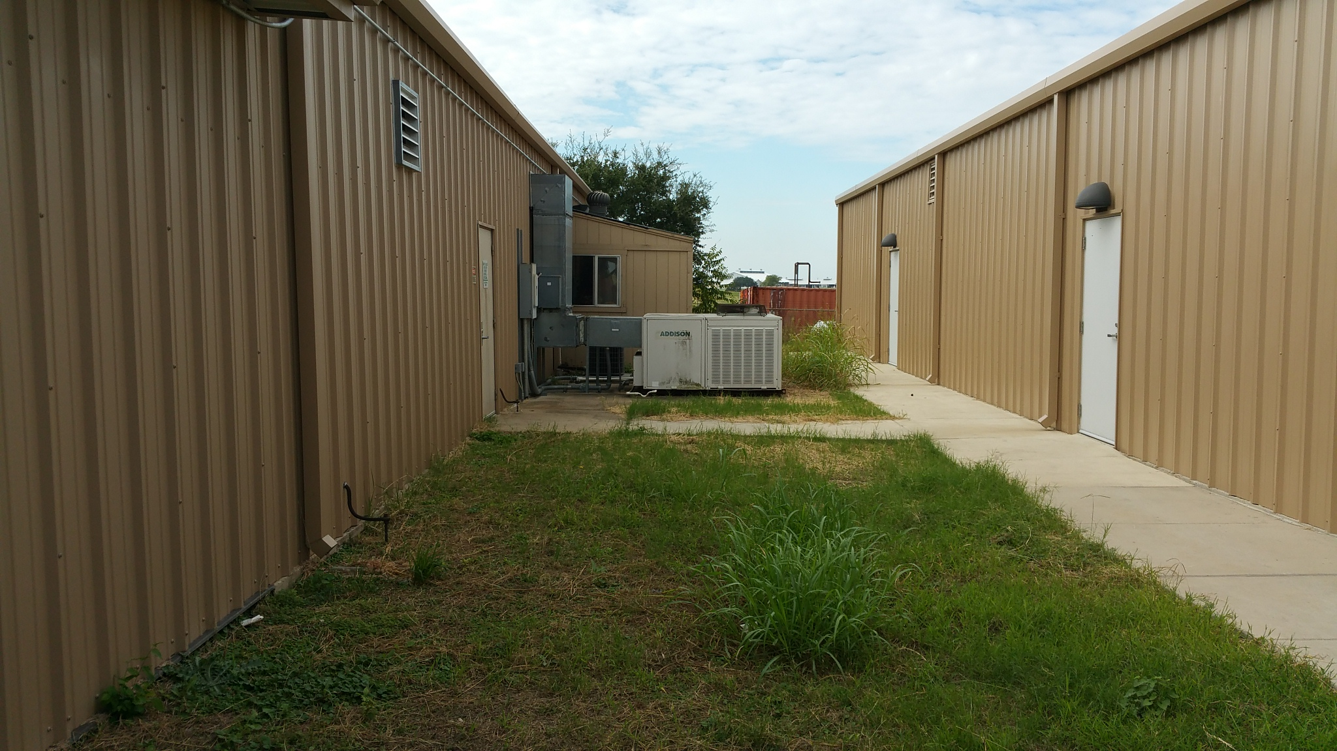
Once the chemicals have been consolidated into larger containers, they are separated into sections to be prepared for shipping. The different areas are: Used Oils, Oxidizers, Corrosives, Flammables and Toxins. This dividing makes sure that chemicals being shipped together are not reactive with each other in the event of a spill.
Figure 3: One –way Air Conditioner System.
In addition to the main building, a spill containment barrier has been built around the facility. Other safety feature include: one-way air conditioner (to make sure fumes are not circulated and compounded) (Figure 3), a failsafe wall built to fail in the event of a blast, no signage indicating the location of the facility (to prevent from terrorist attacks) and response plans.

Regulatory Requirements

The Hazardous Waste Facility operates under RCRA (Resource Conservation and Recovery Act), which gives the EPA the authority to track and control the movement of hazardous materials from “cradle-to-grave”, meaning from the creation of the waste all the way to the final disposal. Also under RCRA, the EPA can control the movement of nonhazardous solid wastes (excluding paint in the State of Texas)².
Described from “cradle-to-grave” is the requirement that all wastes be abled to be tracked back to the producer. This insures the transfer of liability for the proper disposal of wastes. Any person on the transfer of liability for a certain waste is responsible legally for the proper disposal of the waste².
Under RCRA, wastes are classified into multiple types of waste that are to be disposed of in specific ways. These classifications are:
K-wastes: a waste that has come from a specified source with known hazards.
F-wastes: non-source specific wastes that are commonly found in many different sources.
P-wastes: commercial waste chemicals with acute toxicity at low doses.
U-wastes: commercial wastes that may be toxic but also have other hazardous characteristics associated with them.
Required under HSWA, each site disposing of solid wastes must have a Solid Waste Management Plan that must include methods or encouraging resource conservation or recovery and must also include provisions in the permit for any hazardous waste that is accepted³.

Comparisons

The Texas A&M Hazardous Waste Facility is labeled as a Large Quantity Generator. This is the largest class of generators as described by RCRA. As compared to other Universities, Texas A&M is one of the larger producers due to the nature of the large amount of chemical research and the size of the university. Compared to Miami of Ohio, Texas A&M Hazardous Waste Facility handles around ten times as much material¹.

References

- Word of mouth from Dave Rice.
- "Hazardous Waste Regulations." EPA. Environmental Protection Agency, n.d. Web. 20 Nov. 2014.
- Responsibilities, Managing Your Environmental, and Section Vi - Hazardous And Non-Hazardous Solid Waste. Managing Your Environmental Responsibilities: A Planning Guide for Construction and Development: Part 1: Section VI - Hazardous and Non-Hazardous Solid Waste Requirements for Construction Projects (n.d.): n. pag. Hazardous AndNon-Hazardous Solid Waste Requirements for Construction Projects. EPA. Web. 23 Nov. 2014.

